

**George Mason University**

12/9/2022

**Fall**

**2022**

Beakal Abera

Tiarrah Bayne

Jeanie Bailey

Esteban Echandi

**DAEN 690**

**Project Report**

**NLP text classification for SOPs in the Airline Industry**



Table of Contents

Abstract 8

1 Introduction 10

1.1 Background 10

1.2 Problem Space 12

1.3 Research 12

1.4 Solution Space 15

1.5 Project Objectives 15

1.6 Primary User Stories: 16

1.7 Product Vision - Sample scenarios (why would someone want to use this) 16

Scenario #1 16

Scenario #2 16

1.8 Definition of Terms: 17

2 Data Acquisition 17

2.1 Overview: 17

2.1.1 Descriptive Statistics 18

2.2 Field Descriptions: 20

2.3 Data Context: 20

2.4 Data Conditioning 21

2.5 Data Quality Assessment: 21

2.6 Other Data Sources 22

3 Analytics and Algorithms 23

3.1 Methodology Overview 23

3.2 Models/Algorithms 23

3.2.1 BERT 23

3.2.2 Support vector machine (SVM) and Support vector classifier (SVC) 25

3.2.3 Random Forest classifier 26

3.2.4 Principal Component Analysis 27

3.2.5 TextBlob – Parts of Speech tags 27

3.2.6 Nltk Corpus Brown Dictionary – Parts of Speech tags 28

3.2.7 TextBlob – Readability index 28

3.3 Analytics 28

4 Visualization 31

4.1 Embedding visualizations 31

4.2 Machine learning classifiers 32

4.2.1 Support Vector Classifier 32

4.2.2 Random Forest classifier 34

4.2.3 XGBoost classifier 36

4.2.4 Decision tree classifier 37

4.2.5 Stochastic gradient descent 38

4.3 Sequence Analysis 38

5 Findings 41

6 Summary 43

6.1 NLP in a nutshell 43

7 Future Work 45

8 Appendix A: Code References 46

8.1 Github 46

8.2 Readme file 46

9 Appendix B: Risk Section 47

9.1 Sprint 1 Risks 47

9.2 Sprint 2 Risks 47

9.3 Sprint 3 Risks 48

9.4 Sprint 4 Risks 49

9.5 Sprint 5 Risks 51

10 Appendix C: Agile Development 52

10.1 Scrum Methodology 52

10.2 Sprint 1 Analysis 52

10.3 Sprint 2 Analysis 53

10.4 Sprint 3 Analysis 53

10.5 Sprint 4 Analysis 53

10.6 Sprint 5 Analysis 53

11 References 54

Table of Figures

Figure 1: Picture of the life cycle of SOPs from Dr. Lance Sherry's paper Modernizing Development, Deployment and Monitoring of Standard Operating Procedures. [3] 13

Figure 2: Canonical Structure of SOP steps - Procedure Representation Language 13

Figure 3: BERT summary view [10]. 16

Figure 4: Annotation tools available [12]. 17

Figure 5: Flowchart of data acquisition 20

Figure 6: Count of features per parent label. 20

Figure 7: Count of features per label. 21

Figure 8: Features text length frequency 22

Figure 9: Annotated SOP example in JSON format 23

Figure 10: Tokens and Vector dimensions 26

Figure 11: Example of 2-dimensional data. 27

Figure 12: SVC Optimal Hyperplane example. 28

Figure 13: Random Forrest classifier example. 29

Figure 14: Part of Speech tag order. 30

Figure 15: Readability index formula. 30

Figure 16: Parent label associated vector embeddings visualization in 2 dimensions. 33

Figure 17: Label associated vector embeddings visualization in 2 dimensions. 33

Figure 18: Support vector classifier classification report all labels. 34

Figure 19: Support vector classifier classification report noise labels removed. 35

Figure 20: Support vector classifier confusion matrix 36

Figure 21: Random Forest classification report all labels. 36

Figure 22: Random Forest classification report noise labels removed. 37

Figure 23: Random Forest classifier confusion matrix. 38

Figure 24: XGBoost classification report 38

Figure 25: Decision tree classification report 39

Figure 26: SGD classification report 40

Figure 27: Labels sequence frequency - Chronological and Alternative 41

Figure 28: Sub labels sequence frequency - Chronological and Alternative 41

Figure 29: Parent label sequence frequency - Chronological 42

Figure 30: Overall model vs testing SOPs. 43

Figure 31: Cross-validation model comparison. 45

Figure 32: Text classification in a Nutshell 45

Table of Tables

Table 1: BERT Models with their STS benchmark scores. 25

Table 2: Vector 2 rules based on SOPs Flow Chart 29

Table 3: Action label communalities based on parts of speech. 29

Table 4: Labels and methods and algorithms. 30

Table 5: Support vector parameters fine-tuning. 33

Table 6: Random Forest parameters fine-tuning. 35

Table 7: XGBoost parameters fine-tuning. 37

Table 8: Decision tree parameters fine-tuning. 37

Table 9: SGD parameters fine-tuning. 38

# Abstract

Standard operating procedures (SOPs) are step by step instructions used by different organizations to ensure operations are completed in a uniform and safe manner. SOPs are important for safety and efficiency in different critical organizations like Airlines, Nuclear plants, and hospitals. Airline SOPs contain critical information and actions (steps) pilots, and first officers **must** take to ensure safe handling of aircraft.

SOPs lack standardization where the same SOP can have the same information but in different format. Since most SOPs currently in use are paper-based, people who design these procedures usually do not go back to analyze them once published. Our goal is to digitize the paper-based procedures using Natural language processor (NLP) to improve the methodology in which SOPs are engineered and published. This paper uses an NLP model to classify SOP steps into Action, Verify, Waiting, or Trigger category to generate statistics on the structure of SOPs. The airline industry can use these statistics for testing and training new SOPs in the future. To train the NLP model, the team annotated [insert number of annotated SOPs] and collected [insert number of annotated SOPs from Jomana] previously annotated SOPs using UBIAI tool.

*[Write* ***one*** *paragraph of* ***no more than 300 words*** *that summarizes your project. Here are the typical kinds of information found in most abstracts which you should use as an outline as you develop your abstract.*

1. *The* ***context*** *or* ***background information*** *for your research; the* ***general topic*** *under study; the* ***specific topic*** *of your research.*
2. *The* ***central questions*** *or* ***statement of the problem*** *your research addresses.*
3. ***What is already known*** *about this question, what* ***previous research*** *was conducted or shown.*
4. *The* ***main reason(s)****, the* ***exigency****, the* ***rationale****, the* ***goals*** *for your research — why is it important to address these questions? Are you, for example, examining a new topic? Why is that topic worth examining? Are you filling a gap in previous research? Applying new methods to take a fresh look at existing ideas or data? Resolving a dispute within the literature in your field?*
5. *Your* ***research*** *and/or* ***analytical methods****.*
6. *Your main* ***findings****,* ***results****, or* ***arguments****.*
7. *The* ***significance*** *or* ***implications*** *of your findings or arguments.*

*Your abstract should be intelligible on its own, without a reader having to read your entire paper.*

***NOTE: THE DRAFT ABSTRACT IS WRITTEN IN WEEK 12 OF THE PROJECT AND THE FINAL ABSTRACT COMPLETED IN WEEK 13 OF THE PROJECT****.]*

# Introduction

Many industries utilize SOPs (Standards of Procedure) to help train and ensure everyone is aligned on what to do. These are critical in industries such as Airline and Healthcare where job responsibilities are so closely tied to life and the risk of losing it. An effort has been initiated to better understand and analyze SOPs for improvement.

## Background

For our project, we connected with Jomana Bashatah and Dr. Lance Sherry who were actively working on a draft paper titled: METHOD FORMAL ANALYSIS OF THE TYPE AND CONTENT OF AIRLINE STANDARD OPERATING PROCEDURES [1]. As the title suggests, this work looks at Airline Standard Operating procedures (SOPs). The authors detail the usefulness in analyzing the type and content of these SOPs for ‘proficiency in training’ as well as ‘mission efficiency and safety [1]. To execute this analysis effectively, the paper outlines a method in which Natural Language Processing (NLP) would be immensely helpful in extracting the information out of the SOPs written steps.

The methods used for NLP have been developing over decades. Currently, it is necessary to incorporate Machine Learning (ML) with Neural Networks to achieve high performance [2]. NLP has several associated tasks that are analogous to learning how to read. One task Optical Character Recognition (OCR) is like eyesight in it is how a machine can convert text images into a form it can manipulate in a unique way. It is a way of inputting information. Language has the capacity to cover complex nuances when used amongst people. NLP tasks provide ways to capture these nuances for machines to utilize.

To expand upon the usefulness of analyzing the type and content of Airline SOPs, the SOPs from the Airline industry as well as many others are often written in an ad hoc manner [3]. This allows for needed flexibility but can require significant prior knowledge to fully understand the content described. SOPs are commonly used to provide guidance for those training. When learning new things, it is incredibly useful to be able to recognize familiar patterns, even if it is just the sentence structure. The training process to fly a plane obviously has many key milestones and the SOP reference is one part of this process. The ability to systematically assess SOPs will provide inputs to improve the current process. Breaking down the SOP creating and verifying process can move it from a document drafting exercise to an engineering exercise and provide a way to measure improvement [3]. Below is a snapshot of the purposed SOP modernization which visualizes the process steps primed for improvement [3]. The Chargers team is focusing on the section circled in red to convert pdf documents into digitized records for analysis.

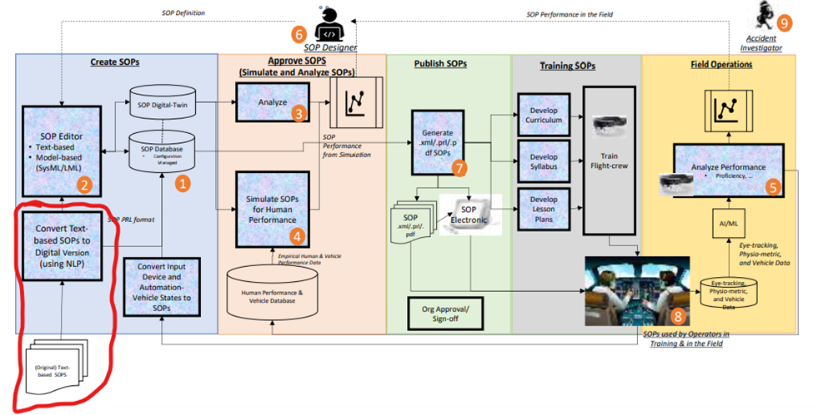

Figure 1: Picture of the life cycle of SOPs from Dr. Lance Sherry's paper Modernizing Development, Deployment and Monitoring of Standard Operating Procedures. [3]

J. Bashatah further describes how to efficiently digitize these text-based SOPs in the context of Procedure Representation Language (PRL) [1],[4]. Figure 2 shows this PRL as labels to use for categorizing SOP steps. UBIAI was introduced in the paper as a tool to annotate procedure steps with the below labels [1]. This not only helped achieve statistical evaluation of SOP step types but also provides a way to train an NLP model.

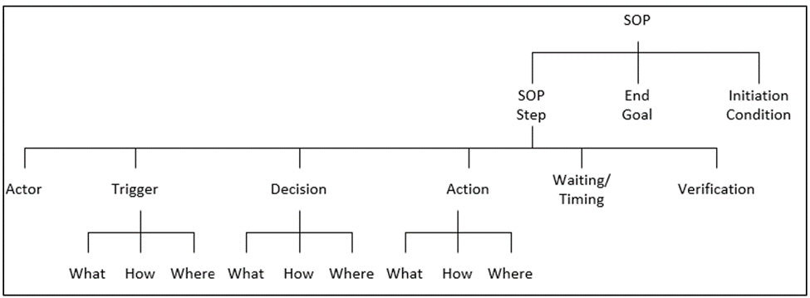

Figure 2: Canonical Structure of SOP steps - Procedure Representation Language

The team was asked to develop an NLP model that can successfully identify these categories of SOP steps. For all modeling, the adage ‘garbage in, garbage out’ applies. To train the model well requires a significant amount of accurate input. Since human interpretation of language can vary, accuracy can be assessed with the UBIAI software’s inter-annotator agreement (IAA) score. This requires multiple people to annotate procedures and returns an assessment of the level of agreement between the annotators.

The process of digitization can take a significant amount of time and effort. Each contribution to the process moves us closer to the goal and allows us to evaluate the steps taken and try to improve.

## Problem Space

Standard Operating procedures (SOPs) are documented step-by-step instructions followed by human operators which are essential to perform critical, repetitive, complex, and emergency-related tasks as efficiently as possible. Due to these aspects and since SOPs play a significant role in any type of process, it is critical to find a systematic method to quantify their information. Nowadays SOPs are created manually by a subject matter expert in the field, which is time-consuming and a tedious process to follow. In addition to this, these documented instructions usually are in formats that are difficult to systematically extract any type of data from. The challenge of the project will be to extract useful statistical information from SOPs to help future research on their automation. When this has been created, it has the potential to reduce costs, improve training, and most importantly, increase safety and reduce human error.

The methodology and logic of the project is going to be applicable to any SOPs, however due to time constraints our focus is going to be based in the airline industry defined by the operation manuals use by pilots like the Flight Crew Operators Manual (FCOM) or Airplane Flight Manual (AFM)

## Research

For the project, most of our research was done regarding 3 primary areas, Standard Operation Procedures (SOPs), text annotation tools and Natural Language Processing (NLP) with a focus on algorithms that can solve a text classification problem. Below is a summary of the most important topics that are applicable to our project.

General Standard Operation Procedures (SOPs)

A standard operating procedure (SOP) is a documentation of instructions on how to execute a certain work procedure. It can act as a checklist that guides team members on how to carry out complex work tasks effectively and safely. Having SOPs in place ensures that the organization stays aligned regarding standards that will help them achieve their goals and objectives [4].

Standard Operation Procedures Components (SOPs)

* Purpose/Objective
* Step by Step procedures
* Coverage
* Responsibilities
* Ownership/Sign-off of key stakeholders

Why are they important?

* Reduce training time
* Maintains consistency and standardization on a process
* Enhances productivity and promotes best practices
* Meet policies and regulations
* Decreases errors and increase safety

Specifically for the Airline Industry the types of Standard Operation Procedures (SOPs) that are going to be focused on are Flight Crew Operators Manual (FCOM) or Airplane Flight Manual (AFM).

Flight Crew Operators Manual (FCOM)

The Flight Crew Operating Manual (FCOM) is issued by the manufacturer as a guideline for operators to develop their own Standard Operating Procedures (SOPs) in accordance with applicable requirements. This source document incorporates aircraft manufacturer guidance on how to use the systems on board the aircraft for enhanced operational safety, as well as for increased efficiency. The FCOM is designed for one specific model, type of operation and configuration [5].

Airplane Flight Manual (AFM)

Airplane Flight manuals and operating handbooks are concise reference books that provide specific information about a particular aircraft or subject. They contain basic facts, information, and/or instructions for the pilot about the operation of an aircraft, flying techniques, etc., and are intended to be kept on hand for ready reference [6].

Natural Language Processing (NLP)

Natural language processing (NLP) is an artificial intelligence area that aids computers in comprehending, interpreting, and manipulating human language. To bridge the gap between human communication and machine understanding, NLP draws on a variety of fields, including computer science and computational linguistics. Natural language processing is not a new subject, but it is progressing quickly thanks to a growing interest in human-machine communication, as well as the availability of massive data, powerful computation, and improved algorithms. Algorithms used for NLP [7].

For our project, the research was focused on Natural language processing (NLP) specifically the text classification area since our project problem to resolve is based on label classification for Action Only, Decision-Action, Action with Waiting-Verification, and Decision-Action with Waiting-Verification on the Flight Crew Operators Manual (FCOM) or Airplane Flight Manual (AFM).

Text classification is the process of categorizing the text into a group of words. By using NLP, text classification can automatically analyze text and then assign a set of predefined tags or categories based on its context. NLP is used for sentiment analysis, topic detection, and language detection [8].

One of the most popular tools that are out there to work with Natural language processing (NLP) specifically - text classification problem is an algorithm invented by Google called BERT. BERT stands for Bidirectional Encoder Representations from Transformers.

Bert is a Machine Learning (ML) model for natural language processing. It was developed in 2018 by researchers at Google AI (Artificial Intelligence) Language and serves as a Swiss army knife solution to 11+ of the most common language tasks, such as sentiment analysis and named entity recognition [9].

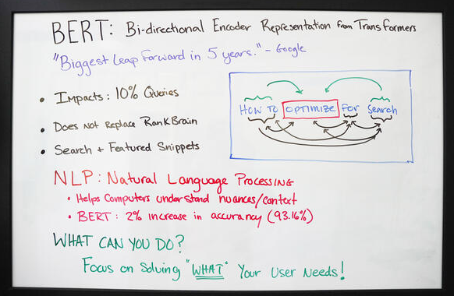

Figure 3: BERT summary view [10].

BERT is made possible by Google's research on Transformers. The transformer is the part of the model that gives BERT its increased capacity for understanding context and ambiguity in language. The transformer does this by processing any given word in relation to all other words in a sentence, rather than processing them one at a time. By looking at all surrounding words, the Transformer allows the BERT model to understand the full context of the word, and therefore better understand searcher intent.

This is contrasted against the traditional method of language processing, known as word embedding, in which previous models like GloVe and word2vec would map every single word to a vector, which represents only one dimension, a sliver, of that word's meaning [10].

Another part of the project in which there was research needed was on how to choose our annotation tool. In this area, we investigated Optical Character Recognition methods and particular annotation tools available in the market and as well open-source options.

Optical character recognition (OCR) is sometimes referred to as text recognition. An OCR program extracts and repurposes data from scanned documents, camera images and image-only pdfs. OCR software singles out letters on the image, puts them into words and then puts the words into sentences, thus enabling access to and editing of the original content. It also eliminates the need for manual data entry. OCR systems use a combination of hardware and software to convert physical, printed documents into machine-readable text. Hardware — such as an optical scanner or specialized circuit board — copies or reads text; then, software typically handles the advanced processing [11].

Annotation Tools Available

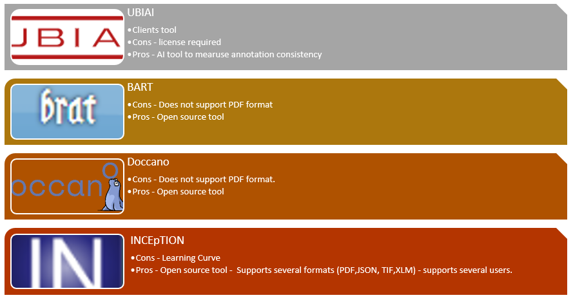

Figure 4: Annotation tools available [12].

## Solution Space

Our NLP model will classify SOPs into the categories and subcategories mentioned above in figure 2. We will use annotated SOPs provided by Jomana and Dr. Sherry and annotate more airline SOPs using UBIAI to train our NLP model. We expect our model to decrease errors resulting from using paper-based SOPs and increase accuracy by using the model for simulation and other engineering purposes.

## Project Objectives

The objective of this project was to develop a NLP model that detects and classifies SOPs into Action, Decision-Action, Action-Waiting-verification, and Decision-Action with waiting-verification.

Currently, the majority of airplane procedures are in paper format where pilots must follow each step accurately. Using paper-based procedures can lead to accidents due to choosing the wrong procedure or omitting a step. “Paper-based procedures are static documents which limit the degree to which the information presented can be tailored to the task and conditions when the procedure is executed” [13]. Our project aims to annotate these paper-based SOPs and convert them into CSV or JSON format to feed our NLP model.

After finishing the project, we assume to achieve a working model to process annotated SOPs which we can use to do engineering, statistics and run simulations to test and improve the accuracy of SOPs.

## Primary User Stories:

Based on the project objectives and value proposition, we developed the following primary user story to guide our project:

* As a flight operator, I want to use computer-based procedures so that I spend less time tracking the correct documentation or procedure.
* As a SOP author or expert, I want to use the NLP model to simulate new SOPs before release so I can test the effectiveness of the SOPs.
* As an airplane manufacturer, I want to implement computer-based SOPs on aircraft to decrease errors and increase safety.

## Product Vision - Sample scenarios (why would someone want to use this)

### Scenario #1

The operating flight crew would benefit from this research. Identifying how past accidents have occurred due to the failure of following directions. Putting specific emphasis on steps that have been missed in the past will allow the operating flight crew to avoid common mistakes.

### Scenario #2

The Federal Aviation Administration (FAA) is the organization responsible for creating the standard operating procedures for airlines to use. The SOPs are in place for the safety of training crew. They should be written in unambiguous language that is easy to understand for all who are using it. Identifying the potential problems from the existing SOPs can aid in the process of writing new ones. Creating a more standardized SOP that is user friendly will help eliminate any uncertainty surrounding the procedures. The caveat to this could be, in creating a new way to write SOPs, new oversights may occur.

## Definition of Terms:

* Standard operating procedure – SOP is a step-by-step instruction used to complete certain processes.
* Natural language processing – NLP gives computers the ability to understand and interpret human text.
* UBAIAI – Computer software used for text annotation.
* Action Only SOP – Step where only an action is explicitly stated in the SOP.
* Decision Action SOP- Step where required information is explicitly stated with the action.
* Action with Waiting Verification SOP- Step where the action has an explicit waiting requirement such as “waiting” followed by an explicit verification.
* Decision Action with Waiting Verification SOP – Step where required information is explicitly stated for the action along with an explicit waiting requirement and verification.
* Optical Character Recognition (OCR) – conversion of images of text into machine-encoded text

# Data Acquisition

## Overview:

Most of the datasets were provided by our client, Jomanna, in JSON format. The remaining datasets were converted from PDF format to JSON by annotating the SOPs using the UBIAI tool. The team developed a process that would allow us to maximize our efficiency with the annotating, the conversion process, and increasing our IAA score. To begin, two of the team members annotate the SOPs, going through the PDF document together. Jomanna did provide the team a flow chart on how to annotate each SOP, however with the team's limited knowledge on the subject manner, we decided it would be beneficial to annotate in pairs to reduce any second guessing. Once that is completed, the second pair will go through and verify what the first pair annotated. After that we discuss any differences, then convert to JSON format. The team merged all the datasets provided and annotated SOPs into one dataset to train our NLP model. To get a more accurate classification model, the team annotated additional SOPs other than the ones provided by Jomanna and Dr. Sherry. The SOPs are from several types of aircraft models and manufactures which makes the dataset diverse and sufficient information for our analysis.

Upload PDF SOPs in UBIAI

Annotate using UBIAI

(Half of the team annotates, the other half reviews and verifies)

Export annotated file in JSON format

Figure 5: Flowchart of data acquisition

### Descriptive Statistics

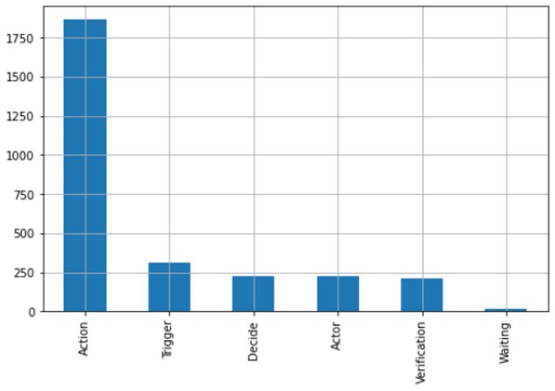

Figure 6: Count of features per parent label.

As seen above, most labels in SOPs are action labels. Airplane SOPs contain many actions pilots, and first officers must follow before and after takeoffs. These can be physical actions such as switching a button off or calling out a word to acknowledge a feature is correct. An analysis of more than 40 suggests that Procedures tend to have more Action (What) labels compared to other labels. The study also found that procedures tend not to contain only action labels. Almost all procedures contain labels other than action labels.

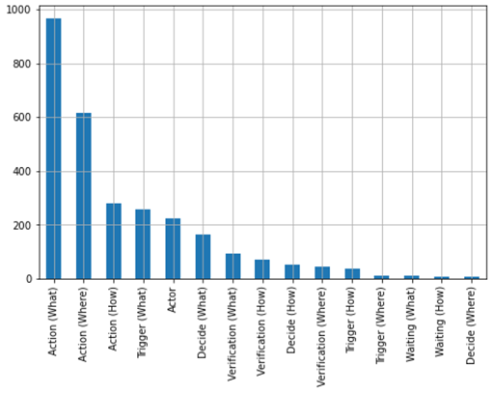

Figure 7: Count of features per label.

*Note: No data point labels for Waiting (Where) found.*

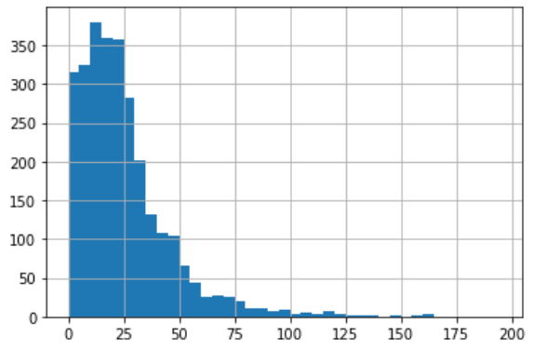

Figure 8: Features text length frequency

## Field Descriptions:

* *Label (Type: string) – Instruction composed by a verb and a sub label determined by either How, Where or What.*
* *Label2 (Type: string) – Instruction composed by a verb only.*
* *Text (Type: string) – Specific text related to the Label, from length 1 to 128 characters.*
* *Document Name (Type: string) – Document or SOP name obtained from the Json file.*
* *Procedure Name (Type: string) – Procedure name extracted from the Document Name.*
* *Airplane Model Name (Type: string) – Airplane model extracted from the procedure name.*
* *Date (Type: datetime) - Date on when the annotation that generated the label was created.*
* *Document Position Start (Type: int) – Numerical start value of the position of the Label.*
* *Document Position End (Type: int) – Numerical end value of the position of the Label.*
* *Index (Type: int) – Index from 1 through the total records of all SOPs labeled.*

## Data Context:

The dataset contains annotated SOPs from different aircraft manufacturers. The annotated file contains details on the type or category of SOP, where it is located within the file, and other details about the aircraft. There are two SOP categories found in Figure 2, verification and waiting, which are not commonly found in the SOPs that we annotated. To mitigate this issue and improve our model accuracy, we had to duplicate some of the SOP lines. Figure 6 is an example of part of an annotated SOP for an A320 aircraft. “Label” and “text” are the two most important sections of the annotated JSON files as we use it to classify or predict SOP categories.

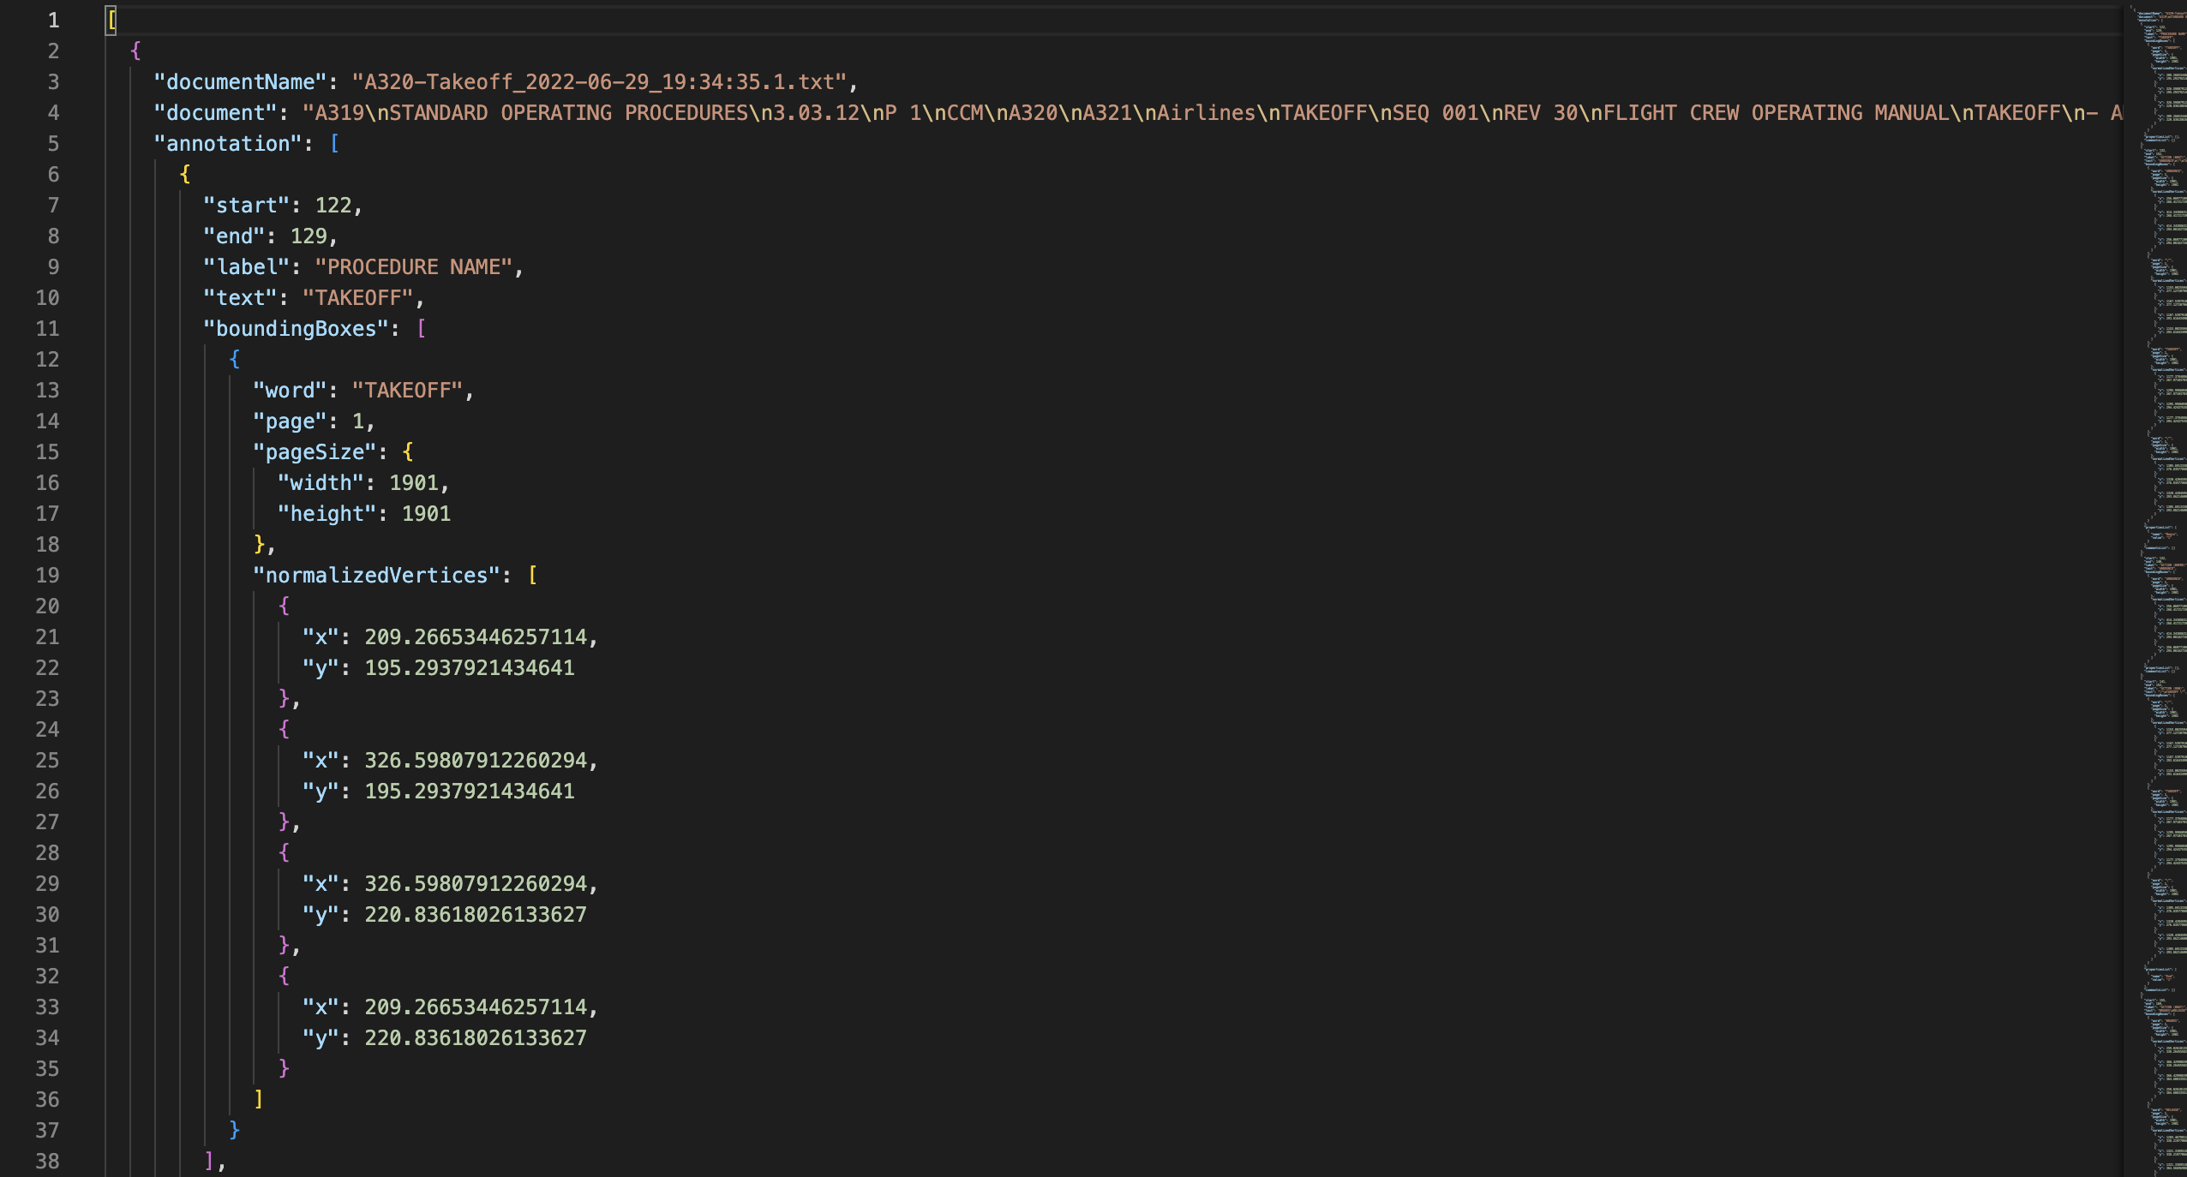

Figure 9: Annotated SOP example in JSON format

## Data Conditioning

Our final dataset was comprised of two types of SOPs. The first was annotated SOPs received from Jomanna. The second was SOPs annotated by the team and then later approved by Jomanna. The first set of SOPs received from Jomanna were already annotated but we had to remove some stop words and perform other data cleaning using Python. This was done to complete the NLP model.

## Data Quality Assessment:

* Completeness: All required values are present in the dataset. Since every SOP is not the same, the excel version of our JSON dataset file might have empty values. This only suggests that every SOP does not contain all the diverse types or categories mentioned in figure 2.
* Uniqueness: All records are unique since all annotated SOPs are unique. There are values that are common within procedures as aircraft manufacturers use similar words in SOPs, but the records are unique as every SOP is unique.
* Accuracy: The annotated SOP was accurate as we used UBIAI score and pair annotation technique to increase dataset accuracy. Our annotated dataset was also checked by Jomana before it was exported to JSON format.
* Conformity: Data types or values are uniform throughout following the standard SOP format.
* Consistency - All columns except 'text' are consistent. All 'index', 'start' and 'end' values contain numerical information.
* Overall Quality: Data generated by 5 different individuals, assessing score with UBIAI score annotation accuracy option.

## Other Data Sources

Other data sources used for the project include the different tables used to complete acronyms and abbreviations which include the definition for those related to the aviation industry. Since the SOPs contain specific language related to the aviation industry, we are using Natural Language processing algorithms

# Analytics and Algorithms

## Methodology Overview

By doing previous research in the Natural language Process (NLP) domain, the team is approaching the main task as a text classification problem. Nowadays there are already several predefined methods that are used when dealing with NLP challenges to try to predict labels and sequences. Text classification, vector semantics, word embeddings, probabilistic language models, and sequence labeling are some examples of usable methods that were accounted for in our project’s research phase.

For the following project, one of the algorithms that stood out when researching text classification and vector embedding was BERT which is a bidirectional encoder representation from transformers that is ahead of most vector models since it analyzes the text from left to right and vice versa which helps the algorithm understand the context from the text In addition to this, the algorithm is built on the transformer architecture and has been pre-trained with a large corpus of over 2.5 MM words. Besides this algorithm there were also used different logical inferences based on how SOPs related to the aviation industry are labeled like the structure of the text and as well the parts of speech that each text contains.

## Models/Algorithms

### BERT

It is Google’s neural network-based technique for natural language processing (NLP) pre-training. BERT stands for Bidirectional Encoder Representations from Transformers. It was opened-sourced last year and written about in [more detail](https://ai.googleblog.com/2018/11/open-sourcing-bert-state-of-art-pre.html) on the Google AI blog. In short, BERT can help computers understand the language a bit more than humans does. [14]

#### Tokenization and Word Embedding

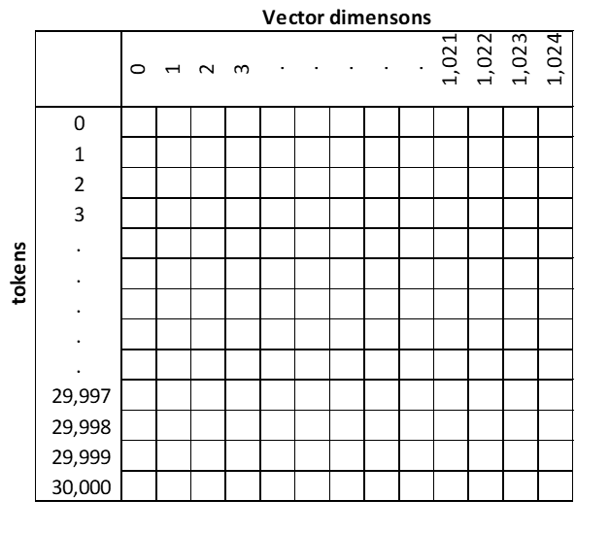

Figure 10: Tokens and Vector dimensions

#### Extracting Embeddings/ Creating vectors

The extraction of the data then is converted into tensors which are is done by a process handled by the huggingface transformers library. This library has a list of pretrained models used to work with vision, audio, and in our case text data.

#### Bert models

For our project, there were 3 different BERT models used shown in figure 7. The best BERT model is called Roberta with the 1000 dimensions vector, and it has an STS benchmark score (Sentence transformers score) of 86.39 points. Bert-large and distilbert had STS scores remarkably close to 86.39. The limitations the team found on using bert-large model is that the words or vocabulary comes from the internet only and this can make the model biased. On the other hand, distilbert is a fast and light transformer model as it uses small parameters compared to the others.

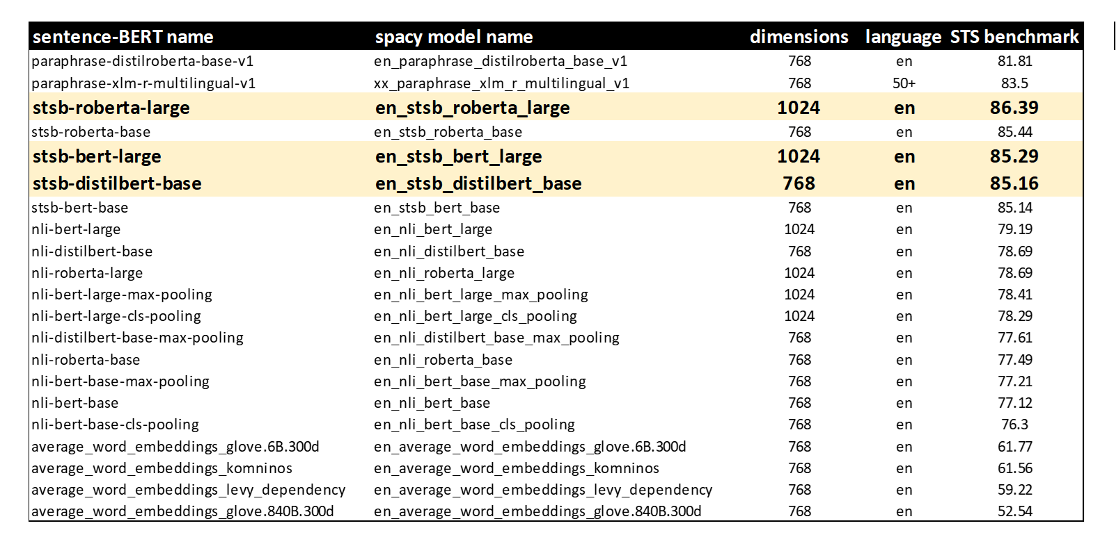

Table 1: BERT Models with their STS benchmark scores.

### Support vector machine (SVM) and Support vector classifier (SVC)

#### Support vector machine (SVM)

Support vector machines (SVM) are used to classify objects or features in N-dimensional space into 2 sides of a hyperplane or line. “The aim of a Support Vector Machine is to devise a computationally efficient way of learning good separating hyperplanes in a high dimensional feature space” [15]. For SVM, data in a low dimension can be transformed to a higher dimension where then we can find a support vector classifier that separates the data into two groups.

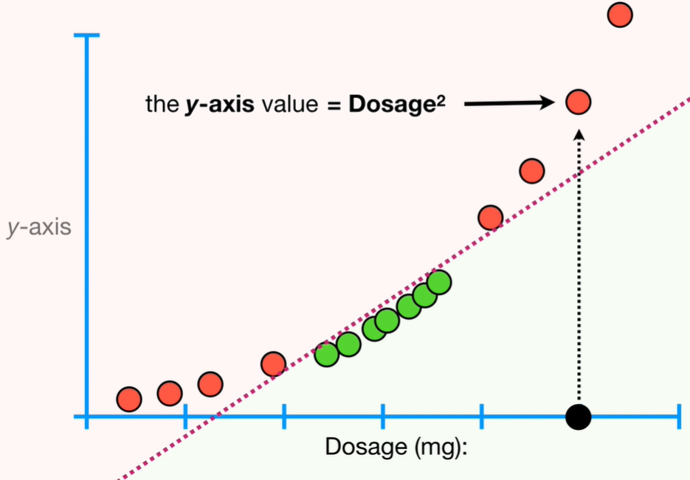

Figure 11: Example of 2-dimensional data.

#### Support vector classifier (SVC)

Support vector classifier (SVC) was trained for this project using sklearn for classifying SOP classes. “SVC works by mapping data points to a high-dimensional space and then finding the optimal hyperplane that divides the data into two classes” [16].

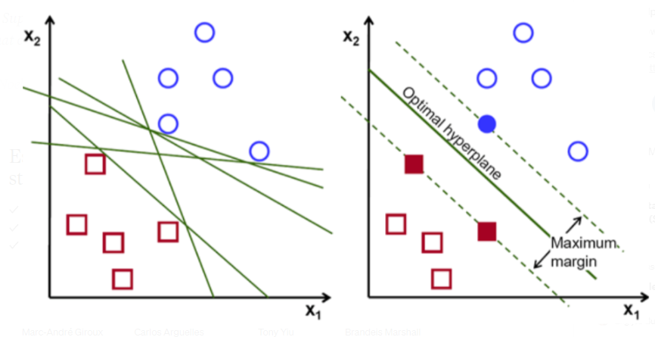

Figure 12: SVC Optimal Hyperplane example.

### Random Forest classifier

Random Forest classifier is another machine learning algorithm used for classification and forecasting business outcomes or decisions. This algorithm selects random samples from a set and constructs a decision tree to get a prediction. This algorithm has advantages over other classification algorithms because it splits the data into many decision tree nodes. Random Forest classifiers have also low instance of overfitting as it aggregates predictions. Our team feared our model would be overfitted due to duplicating data in our training dataset.

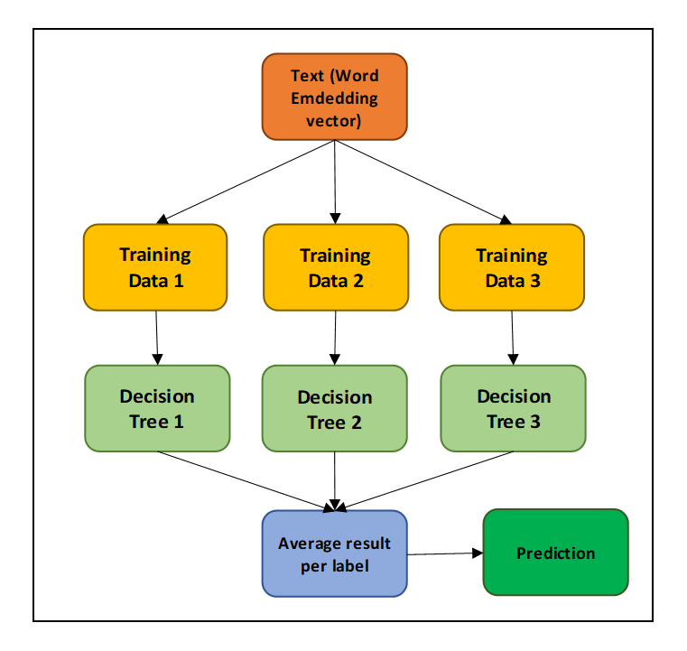

Figure 13: Random Forrest classifier example.

### Principal Component Analysis

Principal component analysis is a statistical procedure that allows you to summarize the information content in large data tables by means of a smaller set of “summary indices” that can be more easily visualized and analyzed [17].

Vector Dimensionality reduction of dimensions n=2 and n=3 will be used as part of our algorithms to reduce the vectors provided by the BERT model for further analysis and visualization purposes.

### TextBlob – Parts of Speech tags

Textblob is a python package that is going to help tag parts of speech (POS) from the different text that the raw data has. Text with this algorithm is tagged based on Parts of Speech tagging context and then assigns the highest probability to what it can be tagged with. For example, if the sentence or text starts with the word pack, the algorithm will prioritize the noun or preposition before the verb.

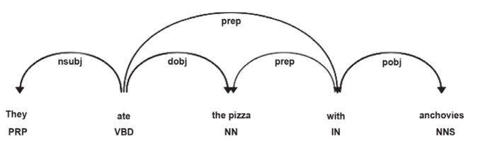

Figure 14: Part of Speech tag order.

### Nltk Corpus Brown Dictionary – Parts of Speech tags

To bypass the normal parts of speech prioritization that Textblob has and to mark any parts of speech that a word can have, we proceeded to use the NLTK corpus for the brown dictionary which has all parts of speech for all words in the English language. With this new method, the team will be able to automatically tag labels that should start with a verb like for example the Action (How) cases which will help to increase the accuracy of the overall model.

### TextBlob – Readability index

In addition, the team also processed the text with a readability score that is based on the formula from Figure 13, this method is going to help clean much more of the data and make sure the algorithm is recognizing the text on the raw data. Any high negative readability score will be eliminated from the calculation when the team confirms with the context of the text and actual SOP document.

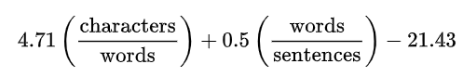

Figure 15: Readability index formula.

## Analytics

SOPs of any industry will contain text, certain rules/standards regarding labels and as well parts of speech that can help us understand different communalities that text might have with the predicted labels.

Our original model only contained 1 vector of information provided by the BERT algorithm associated explicitly with the word embeddings overall text. This is useful for some labels that show high accuracies and are understood by similar contexts portrayed on them. SOPs text in some cases follows certain rules that the original algorithm will not account for.

For this reason, the team decided to create another vector that solely will be looking at these deterministic rules to increase the accuracy of the model. Below are the rules that the algorithm is taking and creating unique vectors for the following text that start with the labels enclosed in Figure 14. Decide (What) labels contained “if” at the beginning or within a sentence. This made the classification process easier for Decide (What) labels. Action (Where) and Verification (Where) labels were harder to predict because the same tools, for example levers or a monitor, used to verify an SOP process can be used to perform an action.

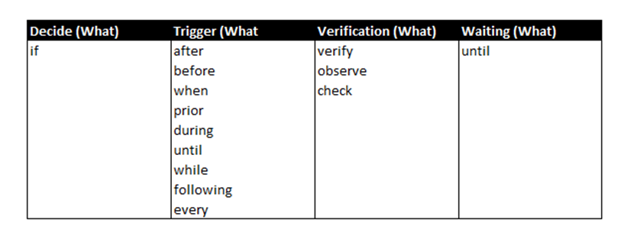

Table 2: Vector 2 rules based on SOPs Flow Chart

In addition to this, to further improve the model part of speech (POS) tagging has also accounted for different labels that have similar patterns. For example, Action (How) labels will be associated with a Verb as they are related to some action being performed by pilot or first officer. Enclosed in figure 15 are some of the rules regarding POS that the team will be incorporating.

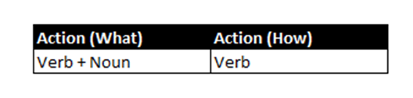

Table 3: Action label communalities based on parts of speech.

This is going to be achieved with a python library TextBlob which has a variety of diverse ways to organize or classify the text associated with our designated labels. For example, the Part-of-speech tagging shows the parts of speech in each labeled text which may be useful to associate parts of speech that are highly correlated with labels like verbs and the action label for instance.

As a summarized view of the analytics and logic mentioned before is the following table.

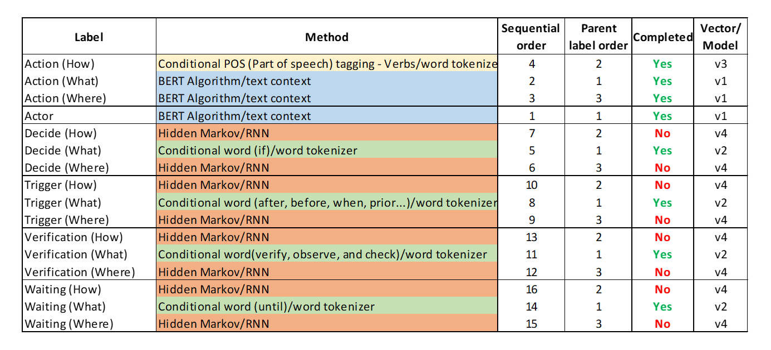

Table 4: Labels and methods and algorithms.

# Visualization

## Embedding visualizations

To visualize the vector embeddings with 1024 values, the following visualizations were created by doing some data transformations by using principal component analysis (PCA) with 2 dimensions.

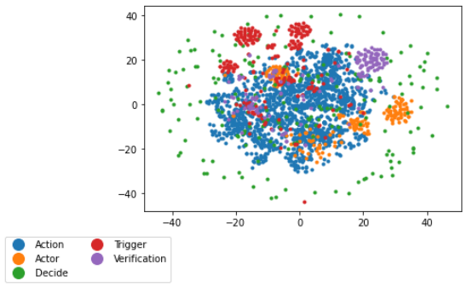

Figure 16: Parent label associated vector embeddings visualization in 2 dimensions.

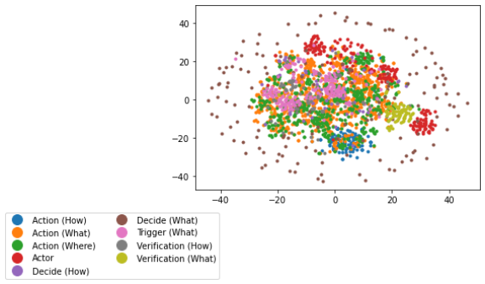

Figure 17: Label associated vector embeddings visualization in 2 dimensions.

## Machine learning classifiers

The following visualizations show the performance of the five machine learning classifiers used following with the sequence analysis for several different label iterations. The team chose to display the models’ prediction accuracy along with each label’s performance to highlight the variation in prediction power depending on the label. The confusion matrices provide more detail around the number of correctly and incorrectly predicted labels. In addition, the fine-tuning parameters are as well shown, that helped increase the f1-scores of each machine learning classifier.

### Support Vector Classifier

In the following heatmap, the precision, recall and F1 score is shown for each of the labels and an overall accuracy is displayed. This shows the results from the support vector classifier model and some labels have extremely high values while others show exceptionally low values. The model struggled with the Trigger (How), Trigger (Where), and the Waiting (What) labels because as shown in section 2, there were not very many of these labels at all. Something interesting that we noticed here is that Decide (Where) also lacked data quantity, but the model showed great accuracy for this label.

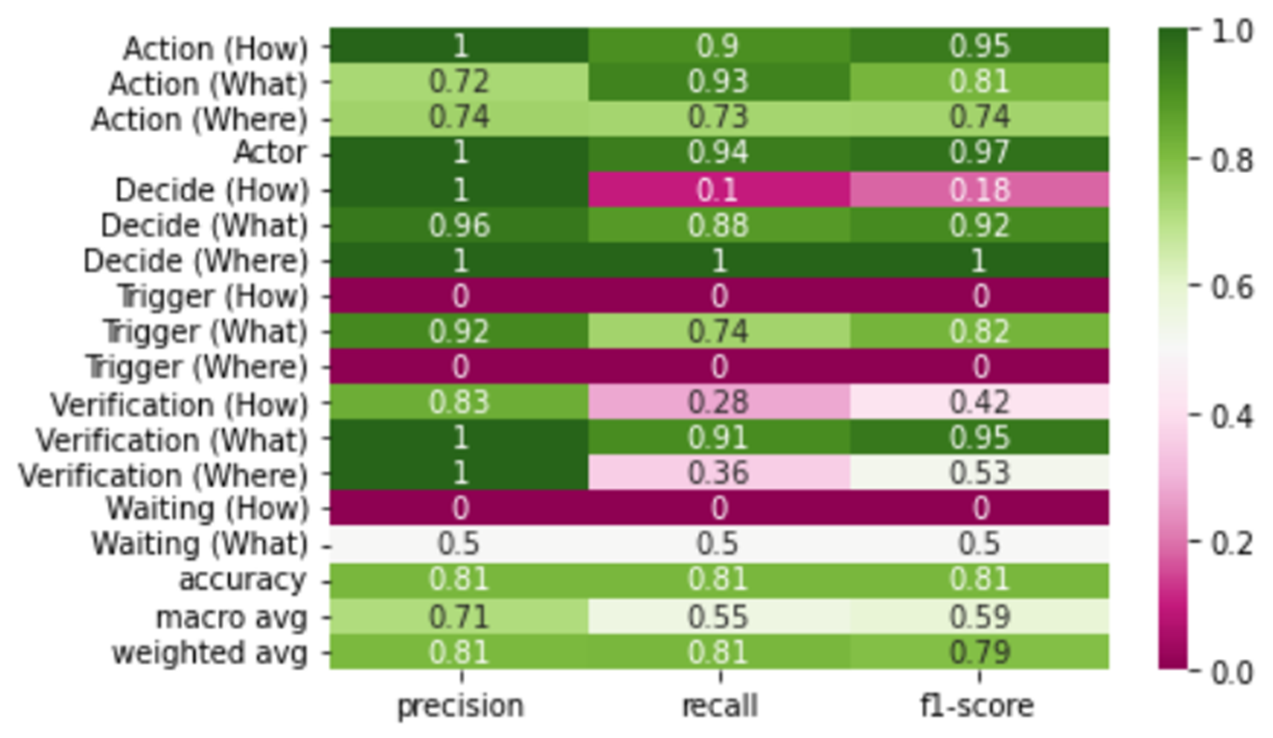

Figure 18: Support vector classifier classification report all labels.

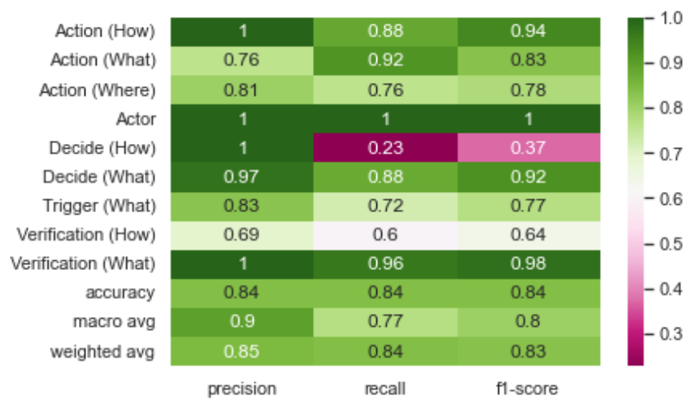

Figure 19: Support vector classifier classification report noise labels removed.

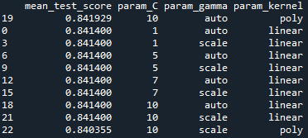

Table 5: Support vector parameters fine-tuning.

The confusion matrix below shows the predicted vs true labels from the same support vector model. Here, the accurate labels are counted across the diagonal and the incorrect labels are counted in the associated spot. For example, there were 12 Trigger (What) labels predicted to be Action (What). The actor is the most accurate label based on the confusion matrix below. This is mainly because the Actor label only had a few unique words related to it and the algorithm can easily detect these words.

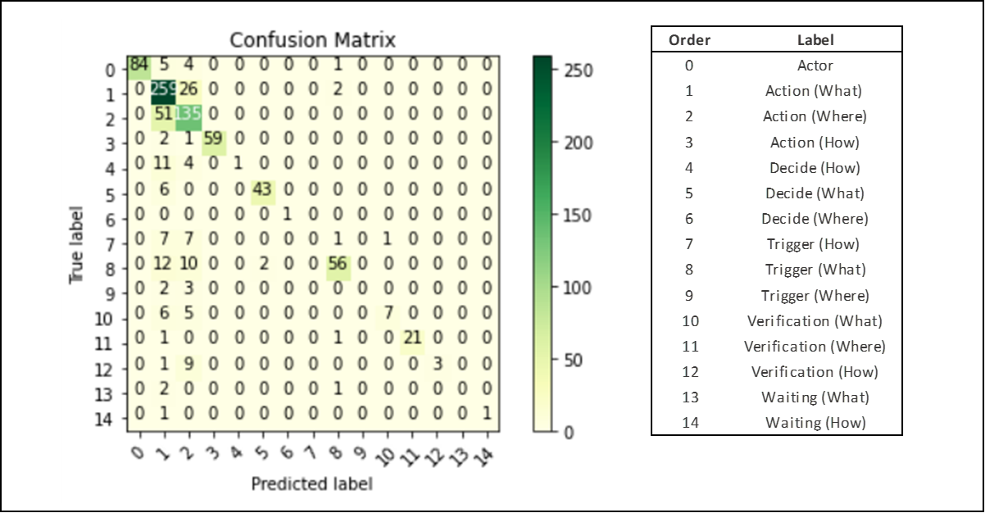

Figure 20: Support vector classifier confusion matrix

### Random Forest classifier

The heatmap below displays the accuracy scores for the random forest classifier. Similarly, to the support vector classifier, there are low scores associated with low the low quantity labels. Compared to Support vector classifier, the random forest classifier has lower precision and overall f1-score.

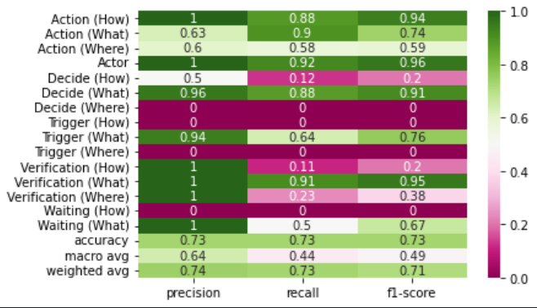

Figure 21: Random Forest classification report all labels.

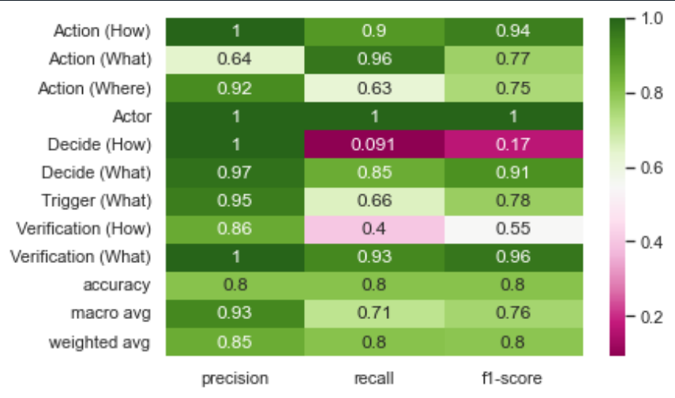

Figure 22: Random Forest classification report noise labels removed.

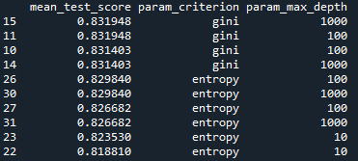

Table 6: Random Forest parameters fine-tuning.

The confusion matrix below displays the results from the random forest classifier. Just like above for the support vector classifier, the confusion matrix shows the number of predicted labels and the true labels. For reasons mentioned above, Actor is great accuracy based on the confusion matrix with all 83 instances being correctly predicted. Verification(where) was also perfectly predicted, and this was a surprising result as the team and algorithm had difficulty during the initial stages of the project correctly predicting or classifying Verification (Where) and Action (Where) labels correctly.

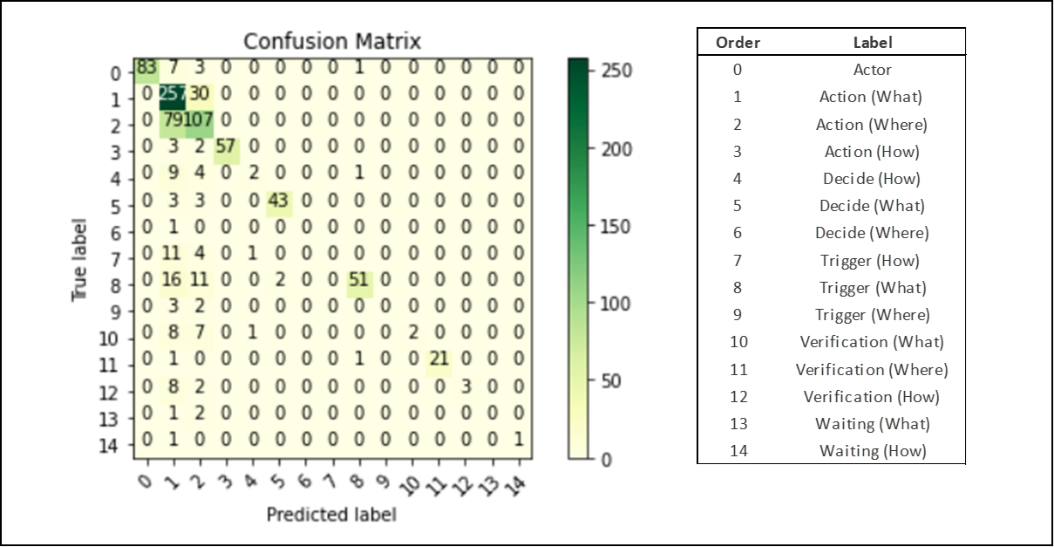

Figure 23: Random Forest classifier confusion matrix.

### XGBoost classifier

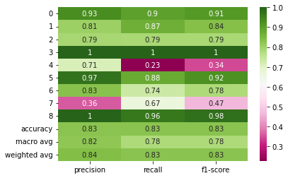

Figure 24: XGBoost classification report

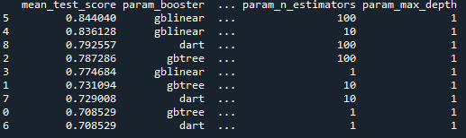

Table 7: XGBoost parameters fine-tuning.

### Decision tree classifier

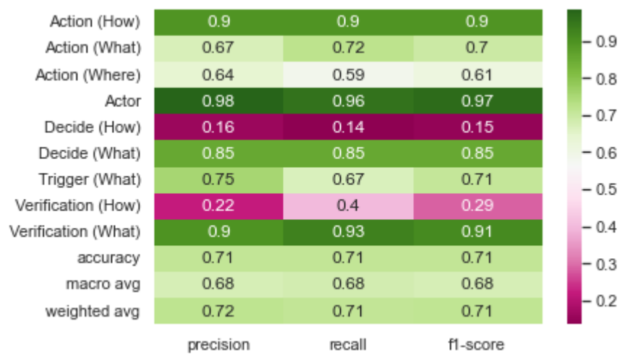

Figure 25: Decision tree classification report

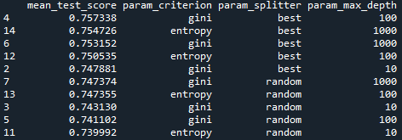

Table 8: Decision tree parameters fine-tuning.

### Stochastic gradient descent

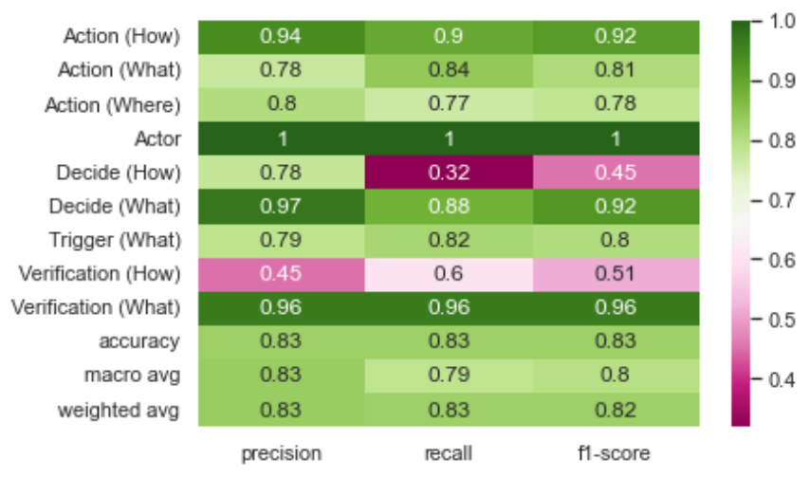

Figure 26: SGD classification report

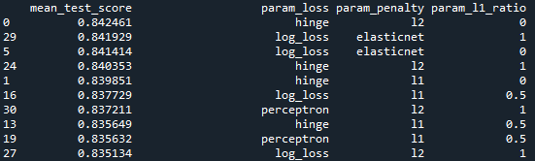

Table 9: SGD parameters fine-tuning.

## Sequence Analysis

For the labels that have poor accuracy scores, the team explored sequential analysis using two separate orders. The chronological order shown on the left in the figure below comes from Jomana’s experience in SOP step structure. An alternative order is shown on the right.

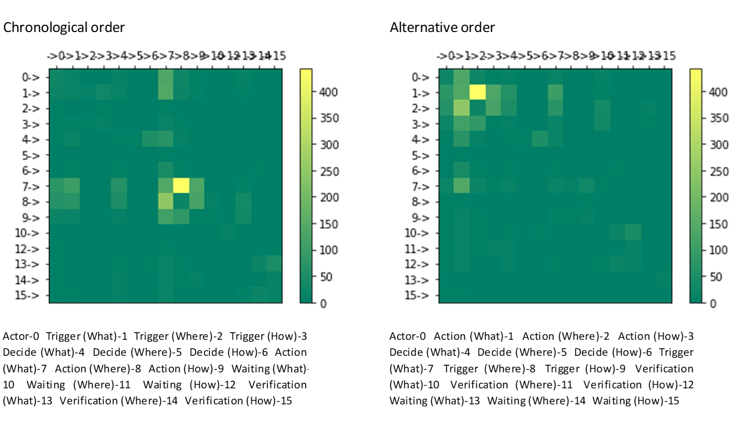

Figure 27: Labels sequence frequency - Chronological and Alternative

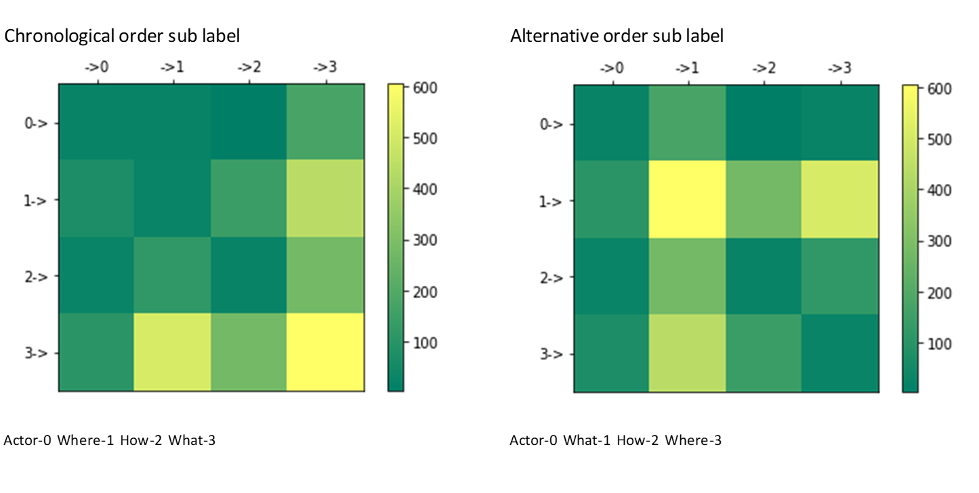

Figure 28: Sub labels sequence frequency - Chronological and Alternative

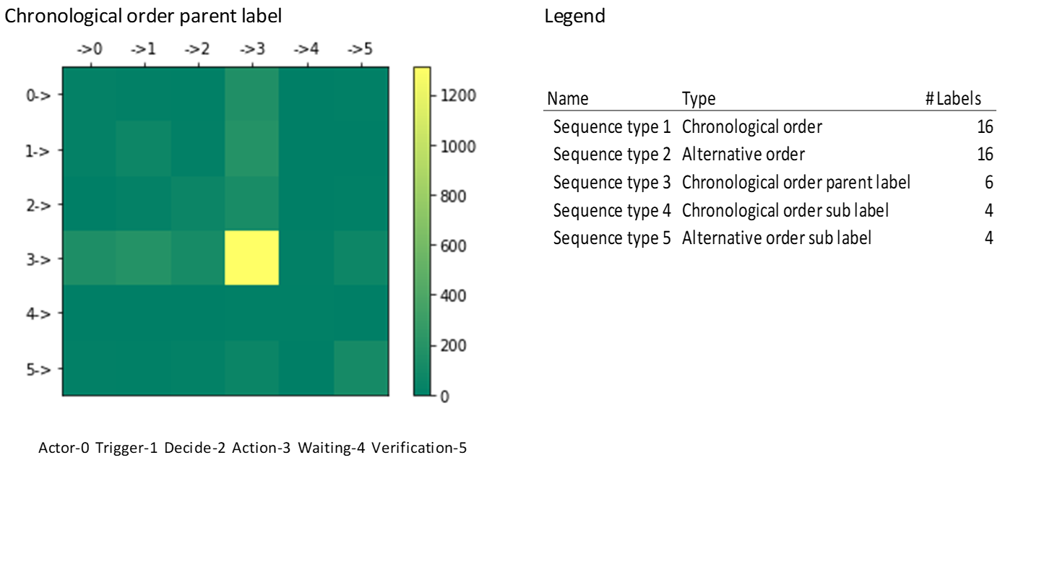Figure 29: Parent label sequence frequency - Chronological

# Findings

Out of 45 annotated SOPs, from different airplane manufacturers and diverse sections of aircrafts, the standout types of labels and label combinations are Action-Decide-Trigger (23%),

Action-Actor-



Figure 30: Overall model vs testing SOPs.

Testing was done on 3 SOPs not included in the training data set of the NLP model. The result was lower than expected as the f1-score of the testing result was 0.61 compared to 0.72 for the overall model. We can also notice the 3 SOPs tested did not have any waiting labels which can result in a lower f1-score. Action labels have outperformed the other labels like the overall model. This is mainly due to the data availability for Action labels in SOPs.

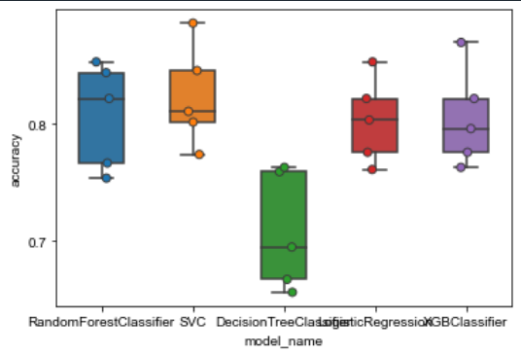

Figure 31: Cross-validation model comparison.

# Summary

*[Summarize your overall results for the reader. What did you discover, prove, disprove, etc.]*

## NLP in a nutshell

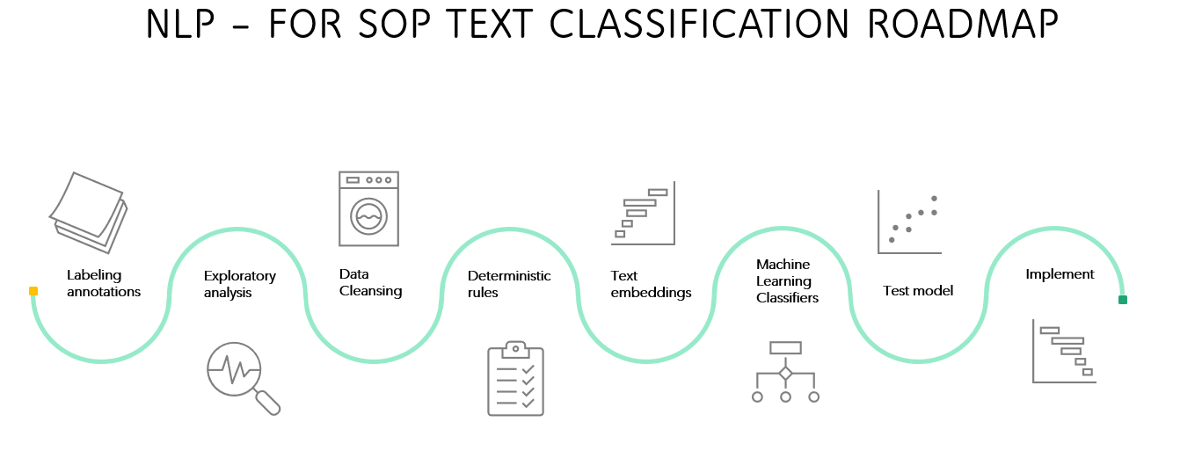

Figure 32: Text classification in a Nutshell

# Future Work

*[Critical section! Propose future work or next step(s) for this project.]*

# Appendix A: Code References

## Github

Link: <https://github.com/Chargers-Team/202270-010-Team-The-Chargers-Project-Development-->

## Readme file

DEAN 690 Fall Project Professor: Brett Berlin Organization: GMU (George Mason University) Center for Air Transportation Systems Research (CATSR) Project POC(s): Dr. Lance Sherry, Director CATSR, [lsherry@gmu.edu](mailto:lsherry@gmu.edu)

Team Chargers has the task of working with Standard Operating Procedures from the airline industry, specifically to solve the following question.

For the airline industry’s Standard Operating Procedures (SOPs) defined as Flight Crew Operators Manuals (FCOM)/ Airplane Flight Manual (AFM) can Natural Language Processes tools be implemented to classify and detect the 4 main activities already preestablished as Action, Decision-Action, Action-Waiting-Verification, and Decision-Action with Waiting-Verification?

Problem Scope

Standard Operating procedures (SOPs) are documented step by step instructions followed by human operators which are essential to perform critical, repetitive, complex, and emergency-related tasks as efficiently as possible. Due to these aspects and since SOPs play a key role in any type of process, it is critical to find a systematic method to quantify their information. Nowadays SOPs are created manually by a subject matter expert in the field, which is a time-consuming and tedious process to follow. In addition to this, these documented instructions usually are in formats that are difficult to systematically extract any type of data from. The challenge of the project will be to extract useful statistical information from SOPs to help future research on their automation when created to reduce costs, improve training and as well most important increase safety and reduce human error. The methodology and logic of the project are going to be applicable to any SOPs, however, due to time constraints our focus is going to be based in the airline industry defined by the operation manuals used by pilots like the Flight Crew Operators Manual (FCOM) or Airplane Flight Manual (AFM).

# Appendix B: Risk Section

## Sprint 1 Risks

|  |  |  |  |  |
| --- | --- | --- | --- | --- |
| **Risk Name​** | **Description​** | **Probability ​** | **Impact​** | **Mitigation​** |
| Scope creep​ | Changes in the project without proper planning​ | Low​ | High​ | - Have a change management plan​  -Create and follow project schedule​ |
| Algorithm selection​ | Find the best algorithm and tool to annotate SOP​ | Low​ | Medium​ | - Research on several tools/algorithms to find the best one that works for our project​ |
| Annotation accuracy​ | Find a way to increase annotation accuracy to have the best training dataset for NLP​ | High​ | Medium​ | - Have multiple team members annotate the same SOP to increase accuracy​ |

Risks for Sprint 1 were assessed and identified based on how the risks would affect our problem statement. Our highest impact risk and low probability was Scope creep. We did encounter a setback where one of our team members left the project early in the project lifecycle. This did not affect our schedule on completing Sprint as we were able to make necessary changes early in the project lifecycle.

Another important risk that came up during our weekly meeting with Dr. Sherry was annotation accuracy. To provide accurate annotated data for our NLP code or analysis, we decided to have multiple team members annotate the same SOP to increase accuracy. Even though this process is time consuming, it increased the accuracy of our annotated dataset. We also researched a lot on the types of annotating and parsing tools we can use to

## Sprint 2 Risks

|  |  |  |  |  |  |
| --- | --- | --- | --- | --- | --- |
| **Risk Name** | **Description** | **Probability** | **Impact** | **Mitigation** | **Status** |
| Annotation Accuracy | UBIAI verification score | High | Medium | 2 team members annotate a SOP, the other 2 team members verify | Resolved |
| NLP Model  Accuracy Score | NLP classification accuracy based on raw data provided | Medium | High | Get more raw data or duplicate current dataset | Resolved |
| Diverse SOP | Currently large volume of action annotations | Medium | Medium | Looking for more SOP that include other decisions | Ongoing |

As we moved into sprint 2, the team discussed a new set of risks. We continued to have two team members annotate a SOP while the other 2 team members verified that annotation. Doing this method allows us to increase our UBIAI verification score. We have resolved this risk. The second risk is the NLP model accuracy score based on the raw data provided. The annotation process is very time consuming, and the team works hard to complete them. However, as we continue to annotate, we must use duplicated data until we complete more annotations. This risk has a high impact level because our model is dependent on the fact that we have enough data to increase the model's accuracy.

The third risk was addressed in one of our weekly meetings with Dr. Sherry. Currently there is a large volume of action labeled annotations. Our current set of SOPs is not very diverse. Jomana is working to look for more SOP that includes some additional labels including trigger, waiting, verification. This risk is not yet resolved, as we continue to receive more SOP from Jomana on a bi-weekly basis.

## Sprint 3 Risks

|  |  |  |  |  |  |
| --- | --- | --- | --- | --- | --- |
| **Risk Name** | **Description** | **Probability** | **Impact** | **Mitigation** | **Status** |
| Model   overfitting | Model will be overfitted when duplicating data | Medium | High | Do not duplicate data | Ongoing |
| Complex data | Some annotated data are too complex to classify and predict | Medium | Medium | Use readability index to remove or clean complex | Ongoing |
| NLP outside help | Find expert in NLP to help with our codes. | High | High | Prepare ask for Dr. Berlin and send a reminder | Ongoing |

In sprint 3 the team has identified three ongoing risks. Currently, this is a risk of the model being overfitted due to data duplication. To resolve this the team will continue to annotate additional SOPs to help diversify the data set. Another risk the team has run into is the complexity of the data set creating complications in the classification and prediction of the model. To combat this risk, we have created a readability index to help clean up the model's complex data.

The team is looking for outside help from a subject matter expect pertaining to NLP models. The team will continue to mitigate these risks as we enter sprint 4.

## Sprint 4 Risks

|  |  |  |  |  |  |
| --- | --- | --- | --- | --- | --- |
| **Risk Name** | **Description** | **Probability** | **Impact** | **Mitigation** | **Status** |
| Model overfitting | Model will be overfitted when duplicating data | Medium | High | Do not duplicate data | Resolved |
| NLP outside help | Find an expert in NLP to help with our codes. | High | High | Prepare ask for Dr. Berlin and send reminder | Reached out to Jinding Xing, who is working on a similar project in nuclear power plant SOPs |
| Diverse SOP | Currently large volume of action annotations | Medium | Medium | Looking for more SOP that include other decisions | Ongoing |

|  |  |  |  |  |  |
| --- | --- | --- | --- | --- | --- |
| **Risk Name** | **Description** | **Probability** | **Impact** | **Mitigation** | **Status** |
| Parsing SOPs | Issue with parsing SOP with Python | High | High | Need to find a way to parse text documents that can be fed to the NLP model | Ongoing |
| Converting pdf SOP to text file | Python script having a tough time with structure of SOPs | Medium | Medium | Add more parameters to script to recognize bold | Resolved |
| TensorFlow | Implementing the TensorFlow algorithm and applying it to the model can take more time than initially planned. | Medium | High | Set a hard deadline for when to apply to model | Resolved |

*[Include the risk table associated with the Sprint. Below the risk table provide a narrative description of how the risks and mitigation plans were identified, what the team got correct, what the team could have done differently, how accurate was the team in identifying the risks, did the team encounter any unanticipated risks, etc. Think of this writeup as a “lessons learned” that you would like to pass along to any project team thinking of doing a similar project.]*

## Sprint 5 Risks

*[Include the risk table associated with the Sprint. Below the risk table provide a narrative description of how the risks and mitigation plans were identified, what the team got correct, what the team could have done differently, how accurate was the team in identifying the risks, did the team encounter any unanticipated risks, etc. Think of this writeup as a “lessons learned” that you would like to pass along to any project team thinking of doing a similar project.]*

# Appendix C: Agile Development

## Scrum Methodology

*[Provide a narrative of the team efforts in using a scrum methodology for a data analytics engineering project. Describe how easy/difficult was it to adapt to the Scrum methodology. Did the team conduct a daily scrum? If not, how often did the team conduct a scrum. Describe how easy/difficult it was to use the YouTrack tool to manage the project. Don’t be limited to just these questions. Think of this writeup as a “lessons learned” that you would like to pass along to any project team thinking of doing a similar project.]*

## Sprint 1 Analysis

Sprint 1 focused on understanding the problem statement and the reason and importance of the project. We tried to identify and make sprints small enough to be completed in one Sprint and independent to make one user story different from another. It was difficult to formulate user stories in our first week, but we have been adapting and practicing creating user stories and the videos on blackboard have been very helpful.

It was not hard to manage the tasks for Sprint 1 because the requirements for this sprint were not as extensive as the coming ones. We were able to define the problem statement with the help of Dr. Sherry and received part of our dataset from Jomana where she also explained what we are required to do with the dataset.

## Sprint 2 Analysis

Sprint 2’s focus was around datasets. We had two main sections of data to work with. First the annotated SOPs in JSON format provided a good start to build an NLP model and perhaps, more importantly, we could begin identifying key areas for improvement. One major improvement we could identify was the necessity to convert abbreviations into full words. Since our project focuses on the Aviation industry, we could find some great resources tailored to our purpose of replacing aviation abbreviations. Something else that stuck-out to us was the uneven quantity of labels. There are significantly more Action labels than Waiting labels, so we started to explore duplicating data to improve model prediction. What is better is to get more actual data because often the phrases label waiting for example would be the exact same phrase. While that makes the model good at detecting that exact phrase, the team felt apprehensive about the usefulness of this approach.

The second data section was the SOPs yet to be annotated. Jomana worked to gather these for us and upload them to UBIAI where we used her flowchart to tag labels. We experienced a bit of a learning curve with annotation accuracy and utilized the Inter Annotator Assessment score to better gauge the annotation accuracy. Working together in groups of two seemed to help decide how to label the variety of phrases. This takes time to align on as a team and is helpful in understanding how the data will be input into the model.

## Sprint 3 Analysis

For Sprint 3, the focus shifted to algorithms and analysis. We continued to annotate SOPs to build the dataset for training the model. The abbreviation replacement code was written in such a way that we could just add abbreviations and their replacements as we needed to. Another key effort was around cleaning the data from UBIAI. A few python packages were identified to help improve the classification of the model. Combining pertinent classifiers like parts of speech and readability scores helped the accuracy of the algorithm. We continued to see improvements to the model as we replaced many abbreviations and corrected spelling errors that were mostly due to UBIAI’s shortcomings on reading in the documents.

## Sprint 4 Analysis

*[Provide a narrative of the team’s efforts during this Sprint. Be sure to include – but not be limited to – how the team identified the User Stories, how well the team performed with the various tasks, how easy/difficult it was for the team to manage their activities during the Sprint, what did the team do correct, what could/should the team have done differently, etc. Think of this writeup as a “lessons learned” that you would like to pass along to any project team thinking of doing a similar project.]*

## Sprint 5 Analysis

*[Provide a narrative of the team’s efforts during this Sprint. Be sure to include – but not be limited to – how the team identified the User Stories, how well the team performed with the various tasks, how easy/difficult it was for the team to manage their activities during the Sprint, what did the team do correct, what could/should the team have done differently, etc. Think of this writeup as a “lessons learned” that you would like to pass along to any project team thinking of doing a similar project.]*

# References

|  |  |
| --- | --- |
| [1] | J. Bashatah and D. L. Sherry, *Method for Formal Analysis of the Type and Content of Airline Standard Operating Proceures,* Fairfax: unpublished, 2022. |
| [2] | D. Kortenkamp, R. P. Bonasso, D. Schreckenghost, K. M. Dalal, V. Verma and L. Wang, "A Procedure Representation Language for Human Spaceflight Operations," p. 8, 2008. |
| [3] | L. D. Sherry, *Modernizing Development, Deployment and Monitoring of Standard Operating Procedures (SOPs),* Unpublished, 2022. |
| [4] | J. Andales, "SOP meaning: Standard operating procedure," Safety Culture, 10 Sep 2022. [Online]. Available: https://safetyculture.com/topics/sop/. [Accessed 11 Sep 2022]. |
| [5] | SKYbrary Aviation Safety, "Flight crew operating manual (FCOM)," SKYbrary Aviation Safety, [Online]. Available: https://skybrary.aero/articles/flight-crew-operating-manual-fcom. [Accessed 1 Sep 2022]. |
| [6] | Federal Aviation Administration, "Handbooks & Manuals," Federal Aviation Administration, [Online]. Available: https://www.faa.gov/regulations_policies/handbooks_manuals. [Accessed 1 Sep 2022]. |
| [7] | U. Mishra, "Top 10 NLP algorithms: Analytics steps," [Online]. Available: https://www.analyticssteps.com/blogs/top-nlp-algorithms. [Accessed 29 Aug 2022]. |
| [8] | P. Neupane, "Text classification in Natural Language Processing," Analytics Vidhya, 11 Dec 2020. [Online]. Available: https://www.analyticsvidhya.com/blog/2020/12/understanding-text-classification-in-nlp-with-movie-review-example-example/. [Accessed 02 Sep 2022]. |
| [9] | huggingface, "Bert 101 - state of the art NLP model explained," hugging Face, [Online]. Available: https://huggingface.co/blog/bert-101. [Accessed 01 Sep 2022]. |
| [10] | B. Lutkevich, "What is Bert (language model) and how does it work?," SearchEnterpriseAI, 27 Jan 2020. [Online]. Available: https://www.techtarget.com/searchenterpriseai/definition/BERT-language-model. [Accessed 02 Sep 2022]. |
| [11] | IBM, "What is optical character recognition (OCR)?," IBM, [Online]. Available: https://www.ibm.com/cloud/blog/optical-character-recognition. [Accessed 29 Aug 2022]. |
| [12] | dida Machine Learning, "The best free labeling tools for text annotation in NLP," dida Machine Learning, [Online]. Available: https://dida.do/blog/the-best-free-labeling-tools-for-text-annotation-in-nlp. [Accessed 06 Sep 2022]. |
| [13] | J. Oxstrand, K. Le Blanc and A. Bly, "Light Water Reactor Sustainability Program.," 14 September 2014. [Online]. Available: https://inldigitallibrary.inl.gov/sites/sti/sti/6278340.pdf. [Accessed 2022]. |
| [14] | B. Schwartz, "Welcome Bert: Google's latest search algorithm to better understand natural language," 23 February 2022. [Online]. Available: https://searchengineland.com/welcome-bert-google-artificial-intelligence-for-understanding-search-queries-323976. [Accessed 18 October 2022]. |
| [15] | M. Hofmann, "Support Vector Machines -Kernels and the Kernel Trick an Elaboration for the Hauptseminar," *Reading Club: Support Vector Machines.,* 2006. |
| [16] | A. Kumar, "SVM Classifier Using Sklearn: Code Examples.," 6 May 2022. [Online]. Available: vitalflux.com/svm-classifier-scikit-learn-code-examples/. [Accessed 2022]. |
| [17] | Sartorius, "What is principal component analysis (PCA) and how it is used?," 18 August 2020. [Online]. Available: https://www.sartorius.com/en/knowledge/science-snippets/what-is-principal-component-analysis-pca-and-how-it-is-used-507186. [Accessed 21 October 2022]. |
| [18] | K. S. Tai, R. Socher and C. D. Manning, "Improved Semantic Representations From Tree-Structured Long Short-Term Memory Networks," 2015. [Online]. Available: https://arxiv.org/abs/1503.00075. [Accessed September 2022]. |
| [19] | L. J., "Introducing BERT: Google’s New AI Algorithm," business2community, 19 Oct 2019. [Online]. Available: https://www.business2community.com/brandviews/shelley-media-arts/introducing-bert-googles-new-ai-algorithm-02254206. [Accessed 03 Sep 2022]. |